Mobile Clinic Electronic Medical Records

User Manual

Table of Contents

1. System Requirements 3

a. iPad Application 3

b. Local Server 3

c. Website 3

2. iPad Application 4

a. Triage 4

i. Registering a Patient 4

ii. Searching for a Patient 5

iii. Creating a Visit 6

b. Doctor 7

i. Selecting a Patient 7

ii. Diagnosing a Patient 7

iii. Assigning a Prescription 8

c. Pharmacy 8

i. Dispensing Medication 8

3. Local Server 9

Getting Started 9

Installing 9

Powering the Server 9

Getting New Users 9

Handling Patients and Visits 10

Cloud Synchronization 11

Saving and Importing 11

Blockers 11

Medication & Prescription 11

4. Website 12

Congratulations on your purchase of our MC-EMR. By incorporating some of the most advanced electronic record technologies, the application is reliable and easy to use. Best of all, the application is affordable and will simplify your tasks. Please carefully read this manual before using your application in order to fully understand the functions and capabilities. Once again, congratulations on your purchase.

# System Requirements

## iPad Application

The minimum recommended requirements for the MC-EMR application is:

1. iPad 2 or higher
2. iOS 6

## Local Server

The recommended platform for the local server is:

1. MacBook Air
2. OS X
3. 4GB RAM

## Website

Any web browser in the following list:

1. Chrome
2. Safari
3. Firefox
4. Internet Explorer

# iPad Application

Once you have installed the MC-EMR app, tap on the icon to launch the application.

You will be prompted to login with the credentials provided to you by an administrator.

## Triage

After you have successfully logged in, you will be presented with the Patient Registration screen. From here, you can begin registering patients, or navigate to a different screen as needed.

### Registering a Patient

Patient registration is the first step in the triage process. Here, you will be required to enter the patients (figure 1):

#### Name

Figure 1

This is accomplished by selecting the text field and entering the name.

#### Family Name

This is accomplished by selecting the text field and entering the name.

#### Village Name

This is accomplished by selecting the text field and entering the name.

#### Gender

This is accomplished by selecting the gender from the segment under the patient picture.

You also have the ability to record additional information such as:

#### Age

To do this, tap on the age button. Then either select the birthdate by using the date spinner, or enter a number for the patient age. Then select the Done button.

#### Photo

To take a patient’s picture, simply tap on the Take Photo button and you will be taken to the camera. When the patient is in focus, tap on the camera icon on the right hand side to take a picture.

If the preview is acceptable, tap on Done, or Retake if the picture is unusable.

#### Face Recognition

In order to better manage patients, you can track patients by their face. We can begin to register the face of the patient by tapping on the “Register Face” Button.

By tapping on “Register”, the camera will start and automatically will take 20 snapshot of the face of the patient. Once this process is complete, the system will notify the triage and will return triage to the triage dashboard.

Figure 3

After filling in all the patient information, tap on “Create Patient”.

### Searching for a Patient

For returning patients, tap on the Search button at the bottom of the Registration screen. Here, you can enter the patient’s name, or part of their name in the corresponding fields; and tap on Search. If the patient is found, they will be shown below.

There is also an option to search for a patient by their faces. To do this, tap on the “Face Recognition” button, then take a picture of the patient and click “use”. If the patient is found, it will be shown in the results.

Figure 4

Now, simply tap on the patient you want to check in to be taken to the New Visit screen.

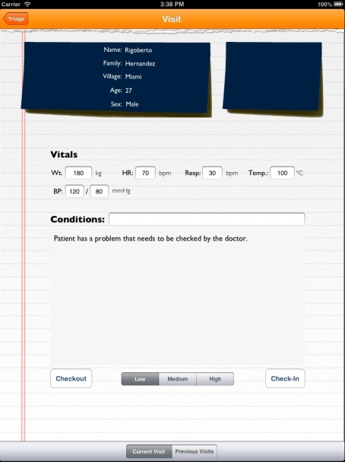

Figure 5

### Creating a Visit

After either registering a new patient, or finding an existing patient, you will want to create a new visit for them.

To create a new visit, enter any information that is deemed relevant, the application currently supports:

#### Weight

#### Heart Rate

#### Respiration Rate

#### Temperature

#### Blood Pressure

You can also enter the patient symptoms in the large text field in the bottom half of the screen, and assign the condition title (figure 5).

The app also provides the ability to see previous visits by selecting the Previous Visits segment at the bottom of the screen. You will be shown that patient’s previous visits, which can assist in documenting their ailment.

If the patient does not require further assistance, tap the Checkout button to complete their visit. Otherwise, select a priority for them from the segment at the bottom of the form, and tap on Check-In to send the patient to a doctor.

## Doctor

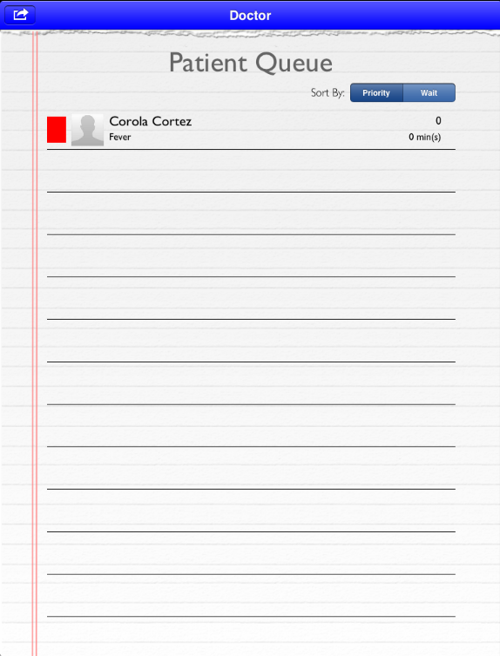One a triage nurse completes her assessment of the patient and submits her results, the patient is put into a queue where a doctor has the ability to play his role in the overall scheme of the system and make his evaluations.

### Selecting a Patient

The first screen the doctor will be presented will be the Patient Queue. Here the doctor will have access to sort patient’s by either:

* Wait Time
* Priority

Each patient cell comprises of four (4) basic descriptors to allow a doctor to quickly glance at vital information that will aid him in the analysis of his/her patient. This information is comprised of:

* Patient’s name
* Condition reported by the nurse
* Name of the nurse/doctor last assisting the patient.
* Wait time since entering the triage.

### Diagnosing a Patient

After selecting a patient from the Patient Queue, the doctor is taken to a diagnosis screen.

Here he/she will have the ability to review vitals taken by the triage nurse, observe the conditions reported by the nurse and be given the ability to write his/her assessment and objective observation.

### Assigning a Prescription

As with every visit, the doctor will need to write a prescription for a patient at the end of a visit. Upon pressing the Submit button in the Diagnosis screen, the doctor will be taken to a view that will allow him/her to write a basic prescription.

This view consists of two parts:

* Prescription
* Medication selection

The process is as follows.

Once the doctor enters the prescription, they will press “drug” which till lead them to a screen with a selection process of medication. Here they are presented with the option to search for a drug or click on the once they so choose to prescribe.

Upon completion of this process, the doctor will press select and be taken back to the prescription screen.

Upon return, the remaining parts of the prescription can be notes. The doctor will then choose the no of times per day to take the medication and the time of day that medication is to be taken. Additionally the prescription gives an optional field to fill for medication notes. Here, the doctor may choose to writ any notes he deems fit for the pharmacist to review in dispensing their medication.

Once the process is over the doctor presses the “send to pharmacy” which will queue them in the pharmacy.

## Pharmacy

The pharmacy is the conclusion of the patient’s visits for the majority of our cases. Here the pharmacist will dispense and decrement that medication from the system as to keep track of the medication of what’s being given out.

### Dispensing Medication

Once the patient is selected from the queue, the pharmacist is shown the patient’s information for verification purposes and is shown the medication the doctor has prescribed. Upon completion of the dispensing and patient’s visit, the pharmacist will “checkout” the patient, saving vital information about the patient’s visit into the system for future statistical analysis.

# Local Server

## Getting Started

This manual is intended for administrators of MC. Any user with mild technical abilities can become a MC administrator. This manual will also describe how to operate the MC-EMR local server. The server is used in conjunction with the client. To learn more about the client please see the client’s user manual.

## Installing

The MC local server application is a Mac OSX app that runs on OS X 10.7 and higher. To install:

1. Drag the application from the ‘Local Server App’ folder and drop it into your computer’s Application folder

In Order to use face recognition, we need to install openCV. Please follow the following steps:

1) Install Mac Ports

<https://www.macports.org/install.php>

2) Once you install Mac Ports, run the following command at command prompt:

sudo port install opencv

3) For Developers Only

1. Click Link Binary with Libraries
2. Choose the required openCV libraries from /opt/local/lib

## Powering the Server

The server is designed to stay on during the duration of the transaction. The system is designed to operate without the server, but for best results the server should be on. The server will automatically turn on once you double click on the application. After 3 seconds a modal dialog will appear asking to accept incoming connections. **You must click Accept.**

The server status will switch from Off to on once the server fully initializes.

*Note: the application does not need active connection to the Internet to carry out its main functionalities.*

## Logging into the Server

When the application has been opened, the server will display a window asking for login credentials. The user must login with their given username and password in order to perform any actions on the Local Server application. Only the Local Server Administrator will have access to login to the application.

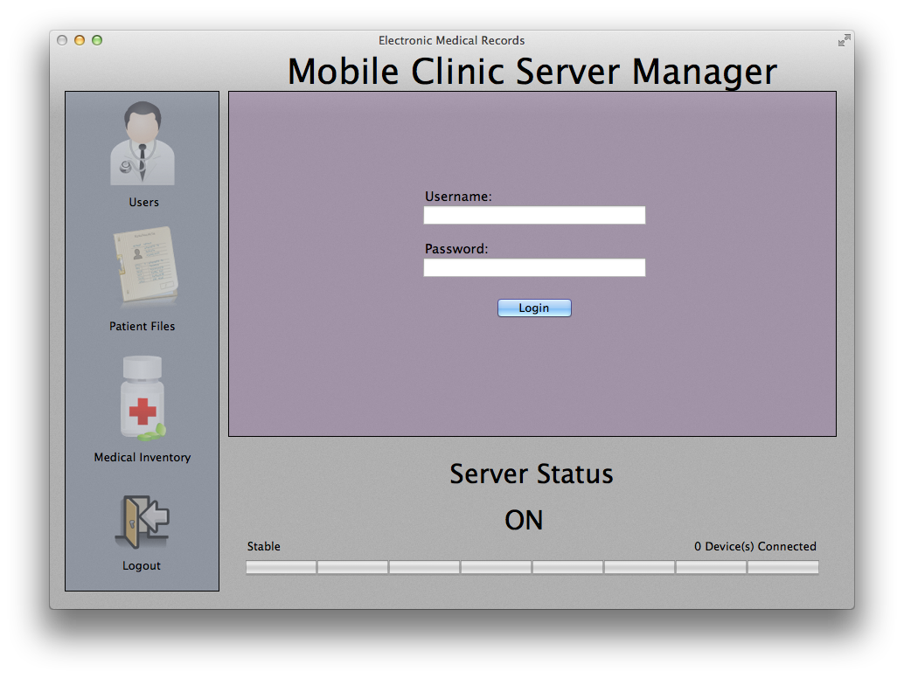

*Note: The server will still communicate function with the iPad applications even if the user has not logged in. The server only needs to be on for its main functionalities to function. Not logging into the application will only prevent actions with the Cloud Server.*

## Getting New Users

If the system is being starting for the very first time, you must sync patients to the server so that the clients can verify the users that are accessing the system. To sync users to the local server:

1. Click the Users icon 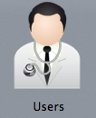
2. Click ‘Cloud Sync’
3. An error may appear stating, “The database cannot handle the following keys…” but just click ok.

# 

## Handling Patients and Visits

The system is designed to handle patient multiple custom data types. When a client registers a new patient, the server stores a patient object. When a client checks in a patient, a Visitation Object is created for that patient. A patient can have many visits but a visit can be tied to only one patient.

As a result during the check in process the visit is linked to the patient object upon saving.

To view all the patients and their associated visits:

1. Click the Patient Icon 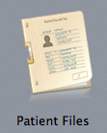

The view shows all the patients in the system, their status, visits and an overview of the visits prognosis

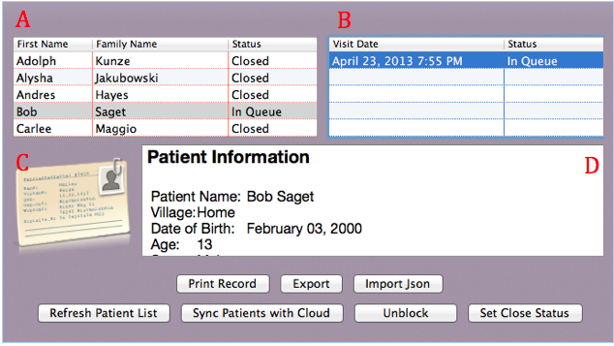

1. Shows the patient and their status
   1. In Queue means that the patient has been checked in and needs to be seen by either the pharmacist or the doctor
   2. Closed means that the patient has been seen by the appropriate personnel and have been discharged
2. For each patient they can hold any number of visits. The visits also show their status as well. For any patient they can have at most only one visit that is in queue. Otherwise there is something wrong and the status that is opened must be closed by clicking the “Set Close Status” button
3. If during triage the nurse takes a photo of the patient, the icon will show the picture of the patient instead the generic contact card
4. This is a read-only text area that will display an overview of the visit that is selected. The visit can does not have to be closed to see an overview. The patients demographical, vitals, and prescription information will be summed into this section and the user will have the option to print it by click the “Print Record” button. Alternatively, The user can also export the information as JSON file.

## Cloud Synchronization

By pressing the “Sync Patient with Cloud” any information will be downloaded from the cloud while new information on the server will be pushed to the cloud. The cloud will generate statistics and allow anyone with Internet access to view any changes. However this feature will only work if you have internet access.

## Saving and Importing

Every 15 minutes the system will back up its information to a JSON file. This is a system wide save. If the system crashes and there is no Internet to sync, you can press the “Import JSON” and select the backup file which is located in Resources folder of the app contents. The system will restore itself to the last save point before its expiration.

## Blockers

Occasionally a patient or visit may become blocked. This means that if a client is trying to access this patient will have a red box indicating it is in use. Only the user that locked the patient can unlock them but as a fail safe the administrator can also unlock the patient as well by selecting the patient and clicking the “Unblock” button.

## Medication & Prescription

The client can currently link only one prescription to a visit. In future versions of the application multiple prescriptions will be linked to a visit. The prescriptions are derived from the available medication.

To see the medication click the Medical Inventory Icon 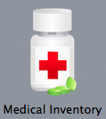

The table will keep track of the available medication. If the medication is not available there are no validation in place to prevent users from accessing the information.

## Logging out

When the user is no longer using the application, he/she should logout. To do this:

1. Click the Patient Icon 

# Website

## Getting Started

This is the Administrative Cloud application of the system. The only requirements you need are that you are a registered User (Admin or Record Keeper) and access to a the internet thru a web browser on a computer or iPad.

## Logging into the system

You will need to be a registered user to log in to the system. If you are not a registered user please ask your administrator to create an account for you.

1. Type in your user name in the User Name field
2. Type in your password into the Password field
3. 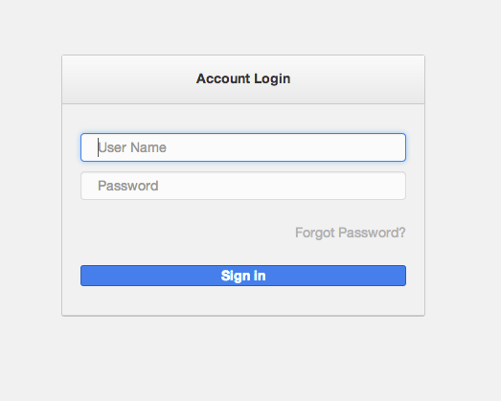Click sign in.

## Using The System

### Dashboard

The Dashboard will give the latest Updated Patient Information that has been synced and backed up into the cloud. Also it will have some visit statistics, like total amount of visits, new visits, and returning visits. From here you will be able to use the system. At the left you will find the Menu with all the options for navigating through the website. The Menu will be static throughout the entire website, meaning it will appear at every page, giving the user the easiness of moving from one subject to another.

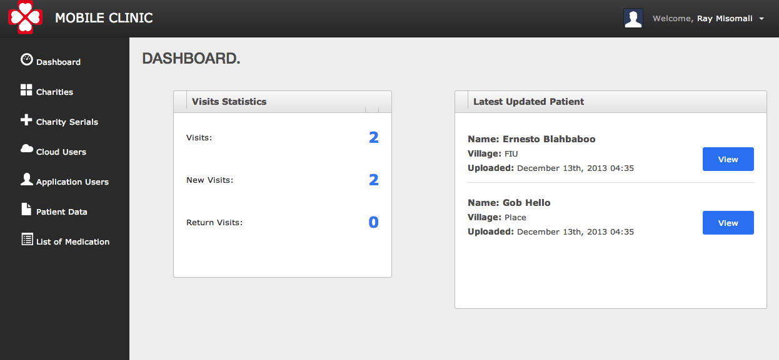

### Charity

Charity is one of the main subjects inside the website. With this new functionality the system will be able to handle multiple charities working with the same system, and at the same time without compromising delicate information. If the user clicks at the Charities link at the Menu, the system will redirect the user to the Charity page. In there the user will be able to create a new charity, or select one already existent for edit or view. The page will also offer a button back that will redirect the user to the Dashboard page.

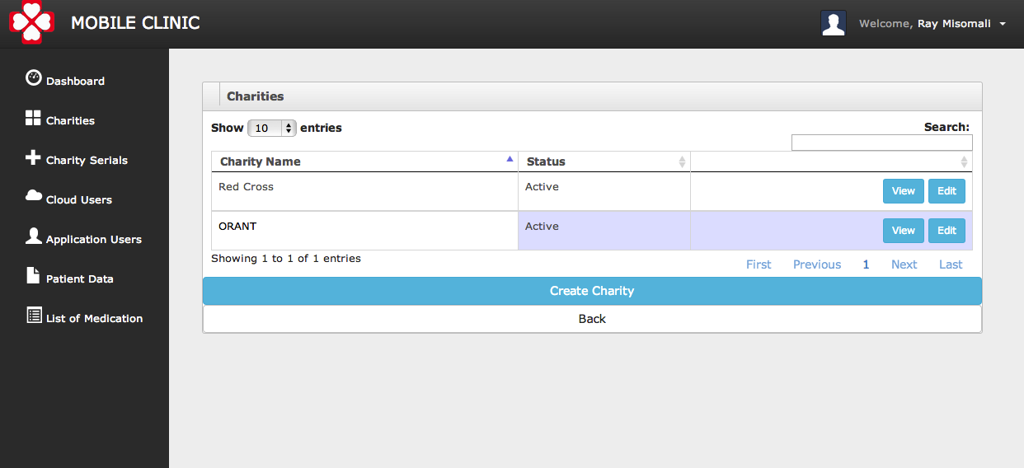

The “Root Administrator” will be able to create multiple charities. On the other hand the “Local Charity Administrator” will not even see the button Charities at the Menu, so he will not be able to handle any operation with charities. This is done so the “Local Charity Administrator” can only perform operation throughout the entire website for his charity. For example he will only be able to create other “Local Charity Administrator” for his charity, or create and modify users for his charity. The “Root Administrator” will be able to perform all kind of operations for all charities.

### Charity Serial

Within this subject the user will be able to register Local Server computers inside the Cloud Application. The purpose of this is that for synchronization we are only allowing computers that are already in the system to be able to synchronize, as a security implementation. “Root Administrators” will be able to register serials for all charities, while “Local Charity Administrators” will be able to register serials only for their charity.

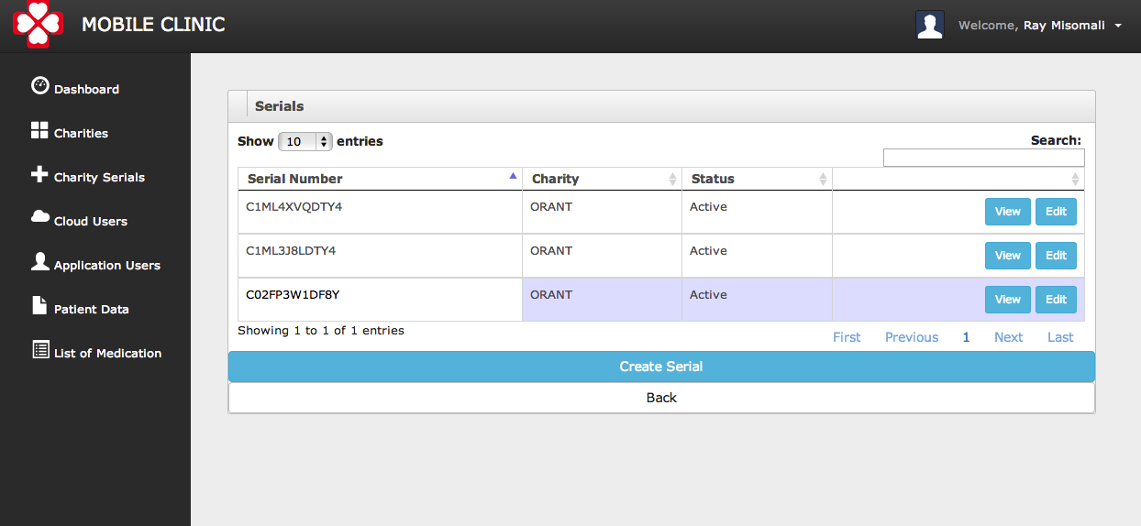

### Cloud Users

In here the user will be able to check all the actual users that are able to access the Cloud Web Application, like the **Root Administrator and the Local Charity Administrator**. It could be some Inactive Users, which are not able to access the Cloud. As in every part of the system the user will be able to create a new user or modify an existent one. As for all the application, the “Root Administrator” will be able to create **Root Administrator and the Local Charity Administrator** for any charity, while the “Local Charity Administrator” will only be able to change or create other **Local Charity Administrator** for his charity only. As a particularity of this part of the website, the “Root Administrator” will be able to change everyone password, but the “Local Charity Administrator” even though he can create other **Local Charity Administrator** he will not be able to change other **Local Charity Administrator** passwords, only his password. This means that if a “Local Charity Administrator” needs to reset his password he needs to ask to the “Root Administrator”.

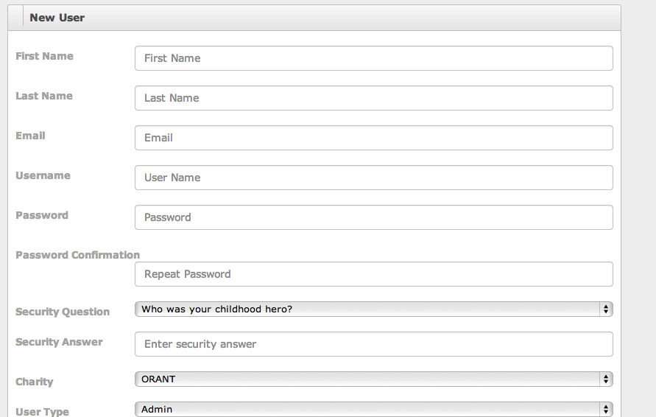

### Application Users

In here the user will find the same functionality as for the Cloud Application but for the Mobile Application Users. In this case Nurse, Doctor, Pharmacist, and Local Admin. The Local Admin will be the only one able to perform synchronization using the Local Server. This is due he is the only one with privileges to Login into the Local Server Application. As all over the system, the “Local Charity Administrator” will only be able to see application users that belong to his charity. He will be able to create application users only for his charity. The “Root Administrator” will be able to create and see all the application users.

### Patient Data

This part of the system the “Root Administrator” and the “Local Charity Administrator” will be able to review patient data, search for patients that are backed up in the system and be able to view any backed up data from the selected patient. The patient data will not be able to be modified within the Cloud Server; it will be view only data. There is functionality to Download all the patients to a CSV file.